Experiment worksheet

3.1 Energy can be transferred

Pages 40–43 and 168–169

Skills lab 3.1: Drawing flow diagrams of energy transfer

What you need

• Station 1: A variety of windup toys

• Station 2: Battery, wires, small buzzer

• Station 3: Tuning fork

• Station 4: Plastic cup, water, salt, aluminium strip, copper strip, 2 wires, multimeter

• Station 5: Plastic windmill, kettle

• Station 6: Toy car, ramp, measuring tape

What to do

Spread around the room are stations with different types of energy. Follow the steps below for each station.

STATION 1

1 Wind up the toys and watch them move.

STATION 2

1 Connect the battery to a buzzer.

STATION 3

1 Gently tap the forked end of the tuning fork on the table.

2 What do you notice happens?

STATION 4

1 Fill most of the cup with water.

2 Add 1 tablespoon of salt to the water.

3 Fold a strip of aluminium and a strip of copper over opposite sides of the cup so that one end is in the saltwater and the other end is on the outside of the cup.

4 Attach wires to the outside edges of the metal strips.

5 Connect the multimeter to the wires and check the voltage reading.

What energy does the multimeter read at this station?

Where did this energy come from?

STATION 5

1 Blow on the plastic windmill.

2 What energy makes the windmill move?

3 Where did this energy come from?

4 Hold the plastic windmill over a boiling kettle while being careful not to burn yourself with the steam.

5 Where is the energy coming from this time?

STATION 6

1 Set up the ramp so that the top end is 10 cm above the ground.

2 Place the car at the top of the ramp.

3 Allow the car to roll down the ramp and along the floor.

4 How far did the car roll?

5 Where did the energy for the car to move come from?

6 How could you increase this energy?

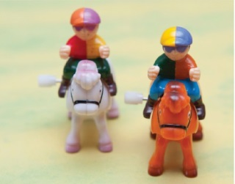

Station 1 What path does the energy take as it is transferred through the wind-up toys?

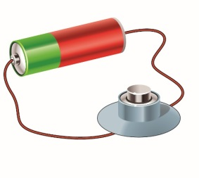  
Station 2 Use wires to connect the buzzer to the battery.

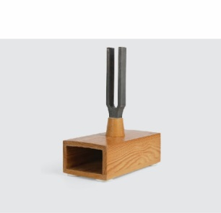

Station 3 Where does the sound energy come/transfer from?

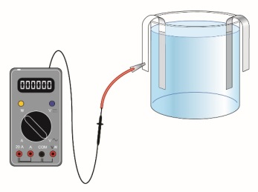

Station 4 Connect the saltwater battery to a multimeter.

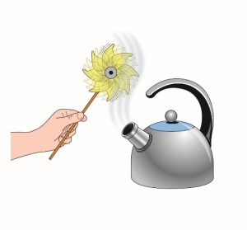

Station 5 A toy windmill acts like an electricity generating turbine.

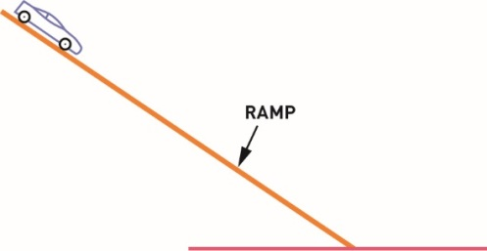

Station 6 What path does the energy take as the car moves down the ramp?

Results

Complete Table 1 and identify the object where you first see evidence of the energy, and the object where you last see the energy.

Table 1

|  |  |  |
| --- | --- | --- |
| Station | Where does the energy come from? | WHICH OBJECT OR PART OF THE OBJECT HAS THE ENERGY LAST? |
| 1 |  |  |
| 2 |  |  |
| 3 |  |  |
| 4 |  |  |
| 5 |  |  |
| 6 |  |  |

Experiment worksheet

3.2 Potential energy is stored energy

Pages 44–45 and 170

Experiment 3.2: What if the amount of elastic potential energy were increased?

Aim

To investigate how elastic potential energy can be used to power a boat.

Materials

• Waxed cardboard (milk cartons work well)

• Scissors

• Rubber band

• Butterfly pins

• Water bath or swimming pool

Method

1 Cut out the waxed cardboard to match the diagram in Figure 1.

2 Put the rubber band around the propeller and attach it to the boat using butterfly pins.

3 Wind the propeller anticlockwise (when viewed from the right side of the boat), place the boat in the water and release it.

4 Measure how far the boat travels.

Inquiry: What if more elastic potential energy was stored in the rubber band propeller?

1 Write a hypothesis for your inquiry.

2 What (independent) variable will you change from the first method?

3 What (dependent) variable will you measure/observe?

4 What variables will you need to control to ensure a fair test? How will you control them?

Results

Complete Table 1.

Then using the space provided, draw a line graph showing the effect of increasing the elastic potential energy of the propeller on the distance the boat travelled.

Table 1

|  |  |  |  |  |
| --- | --- | --- | --- | --- |
| Number of rotations of the propeller | Distance the boat travelled  Attempt 1 | Distance the boat travelled  Attempt 2 | Distance the boat travelled  Attempt 3 | Average distance the boat travelled |
| 1 |  |  |  |  |
| 2 |  |  |  |  |
| 3 |  |  |  |  |
| 4 |  |  |  |  |
| 5 |  |  |  |  |
|  | | | | |

Discussion

1 Did you collect qualitative or quantitative data for this experiment? Explain.

2 Why did you make three attempts at each propeller rotation to determine the average distance travelled?

3 What type of energy was the elastic potential energy converted to?

4 Your hands provided the energy to wind the propeller. Where did this energy come from?

Conclusion

Describe the relationship between the potential energy given to the propeller and the distance the boat moved.

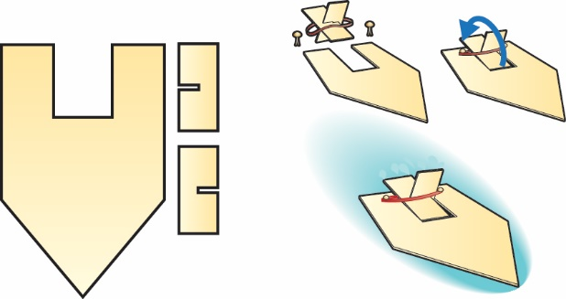

Figure 1 The parts and method of assembly for a rubber band boat

Experiment worksheet

3.3 Moving objects have kinetic energy

Pages 46–47 and 171

Challenge 3.3: Exploring sound energy

What you need

• Tuning fork

• Wooden table or wooden box

• Electric guitar

• Acoustic guitar

What to do

1 Hit a tuning fork on the sole of your shoe and then listen to the sound it makes.

2 Now repeat that process, and then hold the tuning fork so it is standing upright on a wooden table or wooden box. What difference did the table make to the loudness of the sound?

3 Do it again, but see if you can feel the table or box vibrating this time. Why do you think this may have happened?

4 If possible, compare the sound of an unplugged electric guitar to that of an acoustic guitar. Which is louder? Why do you think this is so?

5 Now place your hand on the body of the acoustic guitar as it is played. Can you feel the vibrations?

6 What about with the electric guitar? Does this help you explain why the acoustic guitar may be louder?

Discussion

1 How do you change the way you play a recorder so that it gives out more sound energy?

2 How does a pianist manage to play some notes softly and others very loudly?

3 When you want to yell or speak louder, how do you make the sound coming from your mouth louder?

4 How do drummers make their drums sound louder?

Experiment worksheet

3.4 Energy can be transformed

Pages 48–49 and 171

Challenge 3.4: Energy converters

Consider each device in Table 1, the energy it uses to work (the energy input) and the useful energy it produces (the energy output).

Table 1Common devices that convert energy.

|  |  |  |
| --- | --- | --- |
| Device | Energy input | Energy output |
| Drum |  | Sound |
| Hydroelectricity | Gravitational |  |
|  | Electrical | Sound |
| Light bulb |  | Light |
| Battery | Chemical |  |
| Car engine |  | Kinetic |
|  | Elastic | Kinetic |
| Gas heater |  | Heat |
|  | Nuclear | Light |
| Solar panel | Solar energy | Solar panel Solar energy |
| Phone charger |  | Electrical |
|  |  |  |
|  |  |  |
|  |  |  |
|  |  |  |
|  |  |  |

1 Work in groups to fill in the gaps in the table (ignoring the last five rows).

2 Discuss any patterns you see in the table. For example, are there any energy types that are more commonly ‘inputs’ rather than ‘outputs’?

3 Extend the list with five more devices your group comes up with.

Experiment worksheet

3.5 Energy cannot be created or destroyed

Pages 50–51 and 172

Experiment 3.4: What if you bounced a ball?

Aim

To investigate the energy efficiency of a bouncing ball.

Materials

• Tennis ball

• Metre ruler

• A selection of other types of balls

Method

1 Hold the tennis ball 1 metre above the ground next to the vertical ruler.

2 Drop the ball (do not throw it) on a hard surface.

3 Use the metre ruler to measure how high the ball bounces back. Be careful to avoid parallel error by ensuring your eye is parallel with the ball.

4 Determine the percentage energy efficiency by using the formula below:



Inquiry: Choose one of the following questions to investigate.

• What if another ball was bounced on the same surface? (Does it have the same efficiency?)

• What if the same ball was bounced on another surface? (Does it have the same efficiency?)

Answer the following questions in relation to your inquiry.

Write a hypothesis for your inquiry.

What (independent) variable will you change from the first method?

What (dependent) variable will you measure/observe?

Write a list of variables you will need to control to ensure a fair test. Describe how you will control each variable.

Results

1 Complete the table below

|  |  |  |  |  |  |
| --- | --- | --- | --- | --- | --- |
| Independent Variable  (Surface/Ball) | Height of bounce | | | Average height of bounce | Efficiency (percent) |
| Attempt 1 | Attempt 2 | Attempt 3 |
|  |  |  |  |  |  |
|  |  |  |  |  |  |
|  |  |  |  |  |  |

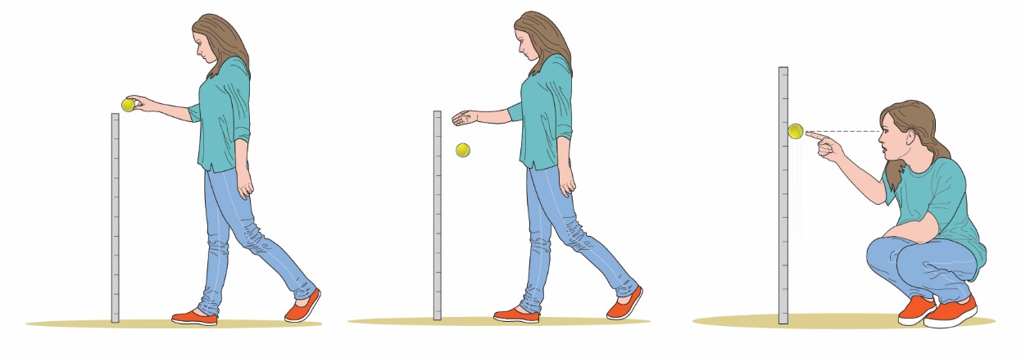

Figure 9.27 Experimental setup

2 Using the space provided, draw a column graph showing how the energy efficiency of the balls changed with your independent variable.\

|  |
| --- |
|  |

Discussion

1 Describe the results of your experiment.

2 Did your experiment provide evidence that supported your hypothesis?

3 What type of energy did the ball have:

• before it was dropped?

• just before it hit the ground?

• as it touched the ground?

4 Where did the waste energy go?

5 Draw a flow diagram of the energy transformation.

|  |
| --- |
|  |

6 Draw a flow diagram of the energy transfer.

|  |
| --- |
|  |

7 Describe the evidence that supported or refuted your hypothesis.

Experiment worksheet

3.6 Energy efficiency can reduce energy consumption

Pages 52–53 and 173

Challenge 3.6: Design an energy efficient house

Design brief

Design and build two identical houses out of cardboard or wood. Add a feature to one of the houses that will make it more efficient in staying cool. Test your design feature by exposing both houses to an energy source (a strong light) and determine the rate of temperature increase for each house.

Criteria restrictions

• Only one feature may be added to the second house.

• The feature must represent a design feature that is currently available to home owners.

• The feature must be proportionate in size to the house.

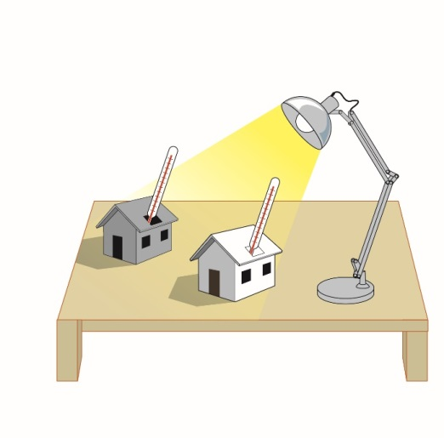

**FIGURE 1** Experimental set up

Questioning and predicting

Which feature will you add?

What materials will you use?

Why do you think your added feature will keep the house cool?

Planning and conducting

How will you measure the temperature of the two houses?

For how long will you expose the houses to the energy source?

Processing, analysing and evaluating

1 Describe the rate of temperature increase in both houses.

2 How efficient was your feature at preventing the transfer of thermal energy?

3 What were the limitations of your design?

4 Would it be possible to create a large-scale version of your design for a real house?

5 If you were doing this experiment again, how would you modify your device? Explain.

Communicating

Present the various stages of your investigation in a formal experimental report.

Experiment worksheet

3.7 Solar cells transform the Sun’s light energy into electrical energy

Pages 54–55 and 174

Challenge 3.7: During what time of the day does the Sun produce the most energy?

What you need

• Solar cell

• Motor with propeller

• Wires

• Sunshine

• Timer

What to do

1 Connect the solar panel to the motor using the wires.

2 Record the weather conditions.

3 Expose the solar panel to sunshine. Count how many times the propeller rotates in 1 minute.

4 Repeat this test at different times of the day, or on different days.

5 Record your data in the following table.

|  |  |  |  |
| --- | --- | --- | --- |
| data | time | revolutions of propeller/minute | weather conditions |
|  |  |  |  |
|  |  |  |  |
|  |  |  |  |
|  |  |  |  |
|  |  |  |  |

Discussion

1 At what time of day does the Sun produce the most light energy?

2 Why should you take readings over several days?

3 Why did you record the weather conditions?

4 Draw a flow diagram that shows the energy transformations for your challenge.

|  |
| --- |
|  |

Experiment worksheet

3.8 Engineers use their understanding of energy to solve problems

Pages 56–57 and 176–177

Challenge 3.8: Leakywater Council swimming pool and waterslide

Design brief

The Leakywater Council invites suitably qualified and experienced students to construct a prototype waterslide to supplement the Leakywater Olympic Swimming Pool. The waterslide must engage children of all ages in safe play. All people who use the waterslide should have enough gravitational potential energy to transform into effective kinetic energy (and speed) at the base of the slide.

Criteria restrictions

The prototype (scale model) should comprise all parts of a successful waterslide that engages children of all ages in safe play. Your prototype tower must be built from the list of materials in Table 1. You must supply your own materials.

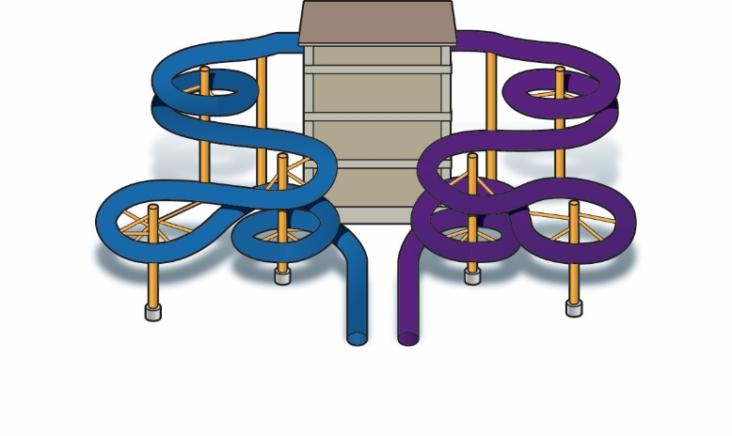

Figure 1 Waterslides convert gravitational potential

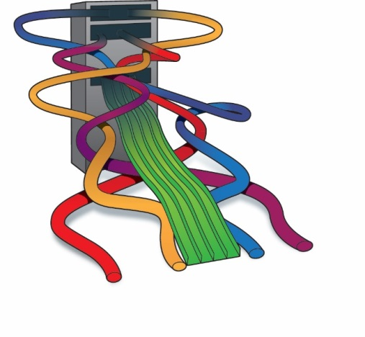

Figure 2 Long waterslides have more friction than short waterslides.Questioning and predicting

• What features do you think a waterslide should have? How many slides should there be?

• What restrictions do you think the council would put on the design of a waterslide? (Remember that as a body loses height it loses gravitational potential energy and gains kinetic energy (i.e. it speeds up). You don’t want people travelling too fast on the slide.)

• How wide does your support tower need to be?

• How high will your model tower be?

Planning and conducting

• What will your waterslide look like?

|  |
| --- |
|  |

• Find examples of waterslides that show the types of designs you could use for your support structure.

• How do the examples support the slides?

• How do the examples provide access to the top of the slide?

• Keep safety in mind. You don’t want someone falling out of the slide.

• How is the structure going to be held together?

• What parts of the design may be difficult to build?

• Are there ways the model could be improved before you begin building?

• What materials will you use to build your prototype? All materials have a cost. Consider the materials listed in Table 1 (and any others you can think of) and choose those that you would use for each component of your waterslide prototype.

Table 1

|  |  |  |  |
| --- | --- | --- | --- |
| Material | Approximate cost | Material | Approximate cost |
| Garden hose | $5 per metre | Pipe cleaners | $2 for 20 |
| Toilet rolls | $0.75 each | Paper clips | $3 for 30 |
| Icy pole sticks | $5 for 20 | Cardboard box | $2 each |
| Toothpicks | $3 for 50 | Lunchbox | $6 each |
| Sticky tape | $2.50 per roll | PVC tube | $8 each |
| Blu Tack | $1 per strip | Plasticine | $4 for 250 grams |
| Wooden rulers | $2 each | Newspaper | $2 each |
| Plastic rulers | $3 each | Chopsticks | $1 each |
| Bubble wrap | $1 per metre | Forks | $1.50 each |
| Wooden rods | $ 1 each | Plastic wrap | $4 per roll |
| Ice cream containers | $4 per container | Plastic bag | $0.10 each |

Processing, analysing and evaluating

1 Is the tower freestanding?

2 How much weight does the tower support? Does it need to be stronger?

3 Is there any room for improvement? What other materials could be used to improve the performance of the tower?

4 What is the cost of the prototype? How would this relate to the cost of the full size water slide?

Communicating

Present the various stages of your investigation in a formal experimental report.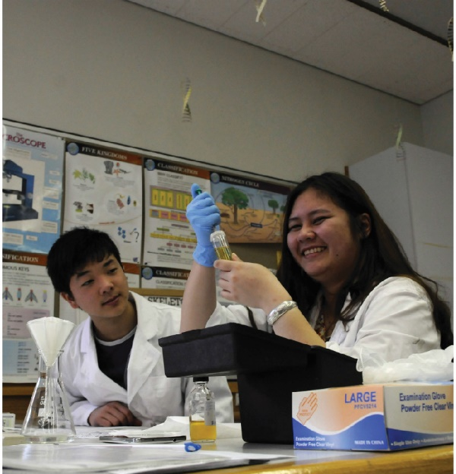

Figure 3You may need to test a variety of materials to determine their suitability for you waterslide.

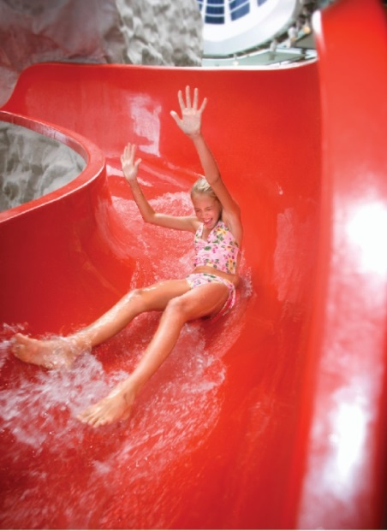

Figure 4The amount of kinetic energy a person has at the bottom of a waterslide often indicates the success of the design.

Experiment worksheet

3.8 Engineers use their understanding of energy to solve problems

Pages 56–57 and 175

Experiment 3.8: Investigating structures and materials using icy pole sticks

This experiment uses icy pole stick beams to investigate elements of structure such as the beams in buildings and bridges.

Aim

To investigate the difference in structural capacity (how much weight it can hold) of the icy pole beam based on its orientation.

Materials

• Icy pole sticks (at least six per group)

• 2 small blocks of timber with a.1.5 mm slot cut across them to hold the ‘beam’

• A bucket with a handle

• A second bucket full of water

• 100 mL measuring cylinder or jug

.

**CAUTION!** IT MAY BE WORTH PERFORMING THIS INVESTIGATION OUTSIDE, OR WHERE THE WATER WILL DO THE LEAST AMOUNT OF DAMAGE

Method

1 Place an icy pole stick across the slots on the two blocks of timber to act as a ‘beam’ on its side.

2 Hang the empty bucket from the centre of the ‘beam’.

3 Add water to the bucket, 100 mL at a time. Record how much water is needed to make the ‘beam’ break.

4 Draw a picture of the break in the icy pole stick.

5 Repeat this procedure twice more to determine an average breaking weight for the ‘beam’.

6 Did the icy pole stick break the same way each time?

Inquiry: What if the ‘beam’ is placed flat?

Write a hypothesis for your inquiry.

What (independent) variable will you change from the first method?

What (dependent) variable will you measure/observe?

Write a list of variables you will need to control to ensure a fair test. Describe how you will control each variable.

Results

Draw a table to show your results.

|  |
| --- |
|  |

Discussion

1 The ‘beams’ were both the same size. What comments can you make about the difference between the two ways the ‘beams’ were tested?

2 Were you surprised by the difference in how much water was needed to make the ‘beams’ break?

3 Which orientation do you think would be more suitable for construction? Use your investigation to justify your answer.

Conclusion

What do you know about how the structural capacity of the beam is affected by its orientation?